Содержание

SimpleTransformation

**DATA**: title_1(10) *VALUE* 'Tutorials'.

**CONCATENATE** '20' DATE0+6(2) DATE0+3(2) DATE0+0(2) *into* data(st).

**CONDENSE** <строка>. - удаляет лишние пробелы между полями, оставляя только 1 пробел.

**CONDENSE** <строка> *NO-GAPS*. - удаляет все пробелы.

**STRLEN**(<строка>).

**SimpleTransformation**

Содержание

# Курсы валют на дату

# <http://extsys-bank-by.it.beloil.by/Services/XmlExRates.aspx?ondate=mm/dd/yyyyy>

# 

# se11

# Структура ZNBRB_RTS

@EndUserText.label : 'ZNBRB_RTS'

@AbapCatalog.enhancementCategory : #NOT_CLASSIFIED

define type **znbrb_rts** {

id : abap.int4;

numcode : abap.char(3);

charcode : abap.char(3);

scale : abap.int4;

name : abap.string(0);

rate : abap.dec(10,4);

# }

# Тип таблицы ZNBRB_RTS_T

# 

# Структура ZNBRB

@EndUserText.label : 'ZNBRB'

@AbapCatalog.enhancementCategory : #NOT_CLASSIFIED

define type **znbrb** {

date : abap.char(10);

currencies : znbrb_rts_t;

# }

# Трансформация ZNBRB_RATES_3

<?sap.transform simple?>

<tt:transform xmlns:tt="http://www.sap.com/transformation-templates" xmlns:ddic="http://www.sap.com/abapxml/types/dictionary" xmlns:def="http://www.sap.com/abapxml/types/defined">

<tt:root name="DAILYEXRATES" type="ddic:ZNBRB"/>

<tt:template>

<DailyExRates>

*<tt:attribute name="Date*" value-ref=".DAILYEXRATES.DATE"/>

<tt:loop ref=".DAILYEXRATES.CURRENCIES">

<Currency>

*<tt:attribute name="Id"* value-ref="ID"/>

<NumCode tt:value-ref="NUMCODE"/>

<CharCode tt:value-ref="CHARCODE"/>

<Scale tt:value-ref="SCALE"/>

<Name tt:value-ref="NAME"/>

<Rate tt:value-ref="RATE"/>

</Currency>

</tt:loop>

</DailyExRates>

</tt:template>

# </tt:transform>

# abap – программа ZTEST_RTS

REPORT **ZNBRB_RTS**.

TABLES: /BIC/ABDCRRTS02.

data:

lt_xml TYPE solix_tab,

ls_rates TYPE znbrb,

ls_rates_t TYPE TABLE of znbrb,

lr_excep1 TYPE REF TO cx_st_match_element,

lr_excep2 TYPE REF TO cx_st_match_attribute,

lv_msg TYPE string.

start-of-selection.

perform load_cbrf_rates_from_site using sy-datum.

form load_cbrf_rates_from_site using iv_date type bldat.

data: lr_client type ref to if_http_client,

lr_response type ref to if_http_response,

l_response type string,

l_url type string,

lv_datetext(10) type c,

lv_url_add(100) type c.

data: lv_xml_string type string,

lv_date(10) type c.

DATA : lv_err_string TYPE string,

lv_ret_code TYPE sy-subrc.

data: st(2) type c.

clear lv_datetext.

if not iv_date is initial.

write iv_date to lv_datetext.

lv_datetext+2(1) = lv_datetext+5(1) = '/'.

st = lv_datetext+0(2). " dd

lv_datetext+0(2) = lv_datetext+3(2). " mm/mm/yyyy

lv_datetext+3(2) = st. " dd/mm/yyyy

* write: / lv_datetext.

concatenate '?ondate=' lv_datetext into lv_url_add.

endif.

concatenate 'http://extsys-bank-by.it.beloil.by/Services/XmlExRates.aspx' lv_url_add into l_url.

*write: / l_url.

call method cl_http_client=>create_by_url

exporting url = l_url

importing client = lr_client

exceptions

internal_error = 1

argument_not_found = 2

plugin_not_active = 3

others = 4.

if sy-subrc ne 0.

write: / 'Ошибка обращения к серверу /cl_http_client=>create_by_url/'.

" message e002 raising create_url_err.

endif.

* Отправка запроса

call method lr_client->send

* exporting timeout = timeout

exceptions

http_communication_failure = 1

http_invalid_state = 2

http_processing_failed = 3

others = 4.

if sy-subrc ne 0.

write: / 'Ошибка запроса к серверу /lr_client->send/'.

" message e003 raising send_error.

endif.

* Получение ответа сервера

call method lr_client->receive

exceptions

http_communication_failure = 1

http_invalid_state = 2

http_processing_failed = 3

others = 4.

if sy-subrc ne 0.

lr_client->response->get_status(

IMPORTING

code = lv_ret_code

reason = lv_err_string

).

* MESSAGE lv_err_string TYPE 'I'.

write: / 'Ошибка получения ответа от сервера /lr_client->receive/'.

"message e004 raising receive_error.

endif.

lr_response = lr_client->response .

l_response = lr_response->get_cdata( ).

* Закрытие соединения

call method lr_client->close

exceptions

http_invalid_state = 1

others = 2.

check not l_response is initial.

lv_xml_string = l_response.

*write : / lv_xml_string.

TRY.

CALL TRANSFORMATION znbrb_rates_3

SOURCE XML lv_xml_string

RESULT DAILYEXRATES = ls_rates.

CATCH cx_st_match_element INTO lr_excep1.

lv_msg = lr_excep1->get_text( ).

CATCH cx_st_match_attribute INTO lr_excep2.

lv_msg = lr_excep2->get_text( ).

ENDTRY.

FIELD-SYMBOLS: <fs> TYPE znbrb_rts.

*write: / ls_rates-date.

concatenate ls_rates-date+6(4) ls_rates-date+0(2) ls_rates-date+3(2) into data(dats).

write: / dats.

types: begin of struct_01,

data0 type c length 8,

f_n_code type n length 3,

f_c_code type c length 3,

f_dscr type c length 100,

f_scale type int4,

f_ratio type f,

end of struct_01.

data:

intab_01 type table of struct_01,

wa like line of intab_01.

data:

l_lines_inserted type int4,

lt_msg type rs_t_msg,

datum type dats.

datum = dats.

CALL FUNCTION 'OIU_ME_CHAR_TO_DATE' "E&P measurement: convert character to date

EXPORTING

i_char = dats " c

IMPORTING

e_date = datum " d

EXCEPTIONS

ERROR_FOUND = 1.

if sy-subrc = 0.

write: / 'datum - ', datum.

endif.

LOOP AT ls_rates-currencies ASSIGNING <fs>.

IF <fs>-numcode = 840.

* write: / ' | NumCode - ', <fs>-numcode, ' | CharCode - ', <fs>-charcode, ' ', <fs>-name, '| Scale - ', <fs>-scale, ' | Rate - ', <fs>-rate.

ENDIF.

* wa-data0 = dats.

wa-data0 = datum.

wa-f_n_code = <fs>-numcode. wa-f_c_code = <fs>-charcode. wa-f_dscr = <fs>-name. wa-f_scale = <fs>-scale. wa-f_ratio = <fs>-rate.

insert wa into table intab_01.

ENDLOOP.

loop at intab_01 into wa.

write: / wa-f_scale, ' ', wa-f_dscr+0(30), ' ', wa-f_ratio.

endloop.

CALL FUNCTION 'RSDSO_WRITE_API'

EXPORTING

i_adsonm = 'BDCRRTS0'

i_allow_new_sids = rs_c_false

i_activate_data = rs_c_true

it_data = intab_01

IMPORTING

e_lines_inserted = l_lines_inserted

et_msg = lt_msg

* e_upd_req_tsn = l_upd_req

* et_act_req_tsn = lt_act_req

EXCEPTIONS

write_failed = 1

activation_failed = 2

datastore_not_found = 3

OTHERS = 4.

skip.

case sy-subrc.

when 1. write: / 'RSDSO_WRITE_API return - write_failed'.

when 2. write: / 'RSDSO_WRITE_API return -activation_failed'.

when 3. write: / 'RSDSO_WRITE_API return - datastore_not_found'.

endcase.

skip. write: / l_lines_inserted, ' lines are was inserted'.

# endform. "load_cbrf_rates_from_site

# [Sample Code for Expert Routine](https://wiki.scn.sap.com/wiki/display/BI/Sample+Code+for+Expert+Routine)

<https://wiki.scn.sap.com/wiki/display/BI/Sample+Code+for+Expert+Routine>

METHOD expert_routine.  
*\*=== Segments ===*  
  
 FIELD-SYMBOLS:  
 <SOURCE_FIELDS> TYPE _ty_s_SC_1.  
  
 DATA:  
 RESULT_FIELDS TYPE _ty_s_TG_1.  
  
*\*$*$ begin of routine - insert your code only below this line *-\**  
... *"insert your code here*  
DATA: DATE0 TYPE D,  
 F_CH(100) TYPE c,  
 BNP_TYPE(4) TYPE n,  
 F_CH_VAL(10) TYPE c.  
  
LOOP at SOURCE_PACKAGE into <SOURCE_FIELDS>.  
 DATE0 = <SOURCE_FIELDS>-DATE_.  
 F_CH = <SOURCE_FIELDS>-OP_CH.  
 BNP_TYPE = '0001'.  
 F_CH_VAL = <SOURCE_FIELDS>-F_80.  
  
 CONCATENATE '20' DATE0+6(2) DATE0+3(2) DATE0+0(2) into DATE0.  
 RESULT_FIELDS-DATE0 = DATE0.  
  
 REPLACE '%' WITH '' INTO F_CH.  
 CONDENSE F_CH NO-GAPS.  
 RESULT_FIELDS-F_CH = F_CH.  
 RESULT_FIELDS-/BIC/BNP_TYPE = BNP_TYPE.  
 RESULT_FIELDS-F_CH_VAL = F_CH_VAL.  
  
 append RESULT_FIELDS to RESULT_PACKAGE.  
  
 clear DATE0.  
 clear F_CH.  
 clear BNP_TYPE.  
 clear F_CH_VAL.  
ENDLOOP.  
*\*$*$ end of routine - insert your code only before this line *-\**  
 ENDMETHOD.

# Converting ABAP code into AMDP scripts in SAP BW transformations

<https://visualbi.com/blogs/sap/sap-bw-hana/converting-abap-code-amdp-scripts-sap-bw-transformations/>

Unlike ABAP transformation, where row level processing is possible, in AMDP, data is processed as a package using an INSERT AS SELECT on the calculation scenario generated.

### **Delete**

In ABAP, the **DELETE** statement is used to remove certain records from an internal table based on certain conditions. In the AMDP script, the DELETE statement is replaced by SELECT statements.

***ABAP***

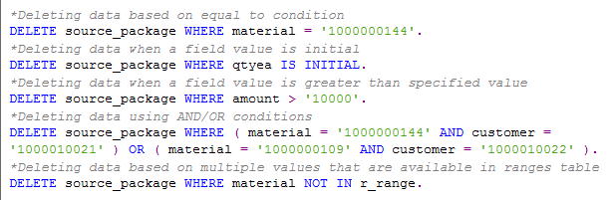

***AMDP***

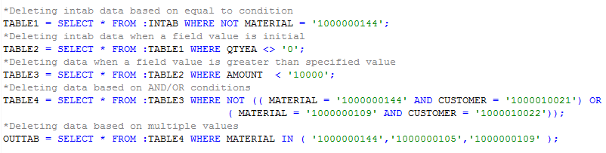

### **IF-ELSE Statements**

The IF-ELSE-ENDIF statements are used in ABAP to process different logical blocks of code based on different conditions. In AMDP code, the IF-ELSE statements can be replaced by CASE-END statements.

***ABAP***

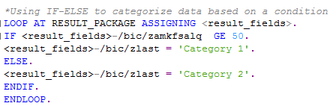

***AMDP***

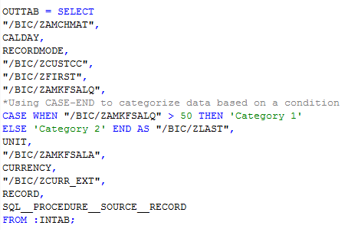

Example 2

Nested if-else can also be commonly seen as a part of ABAP code and CASE statements can be used to replace nested if-else statements as well. An example with nested CASE is shown below.

***ABAP***

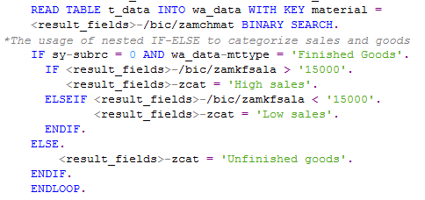

***AMDP***

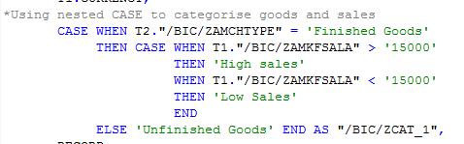

### **Sort, Delete adjacent duplicates and For all entries**

Sort statements can be replaced by the “ORDER BY” clause in AMDP.

Delete adjacent duplicates in ABAP is achieved in the AMDP script using the ROW_NUMBER() and OVER() functions. The “PARTITION BY” clause divides the data into groups and ROW_NUMBER() clause assigns a row number for the partitioned data. If the partition by clause is not used, then the entire set is considered as a single group of data.

***ABAP***

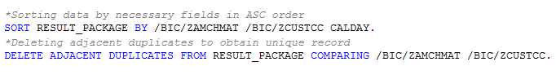

***AMDP***

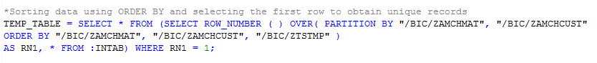

### **For all entries**

In ABAP, FOR ALL ENTRIES statement is used to fetch corresponding data for all the records in the source or result package. The same functionality can be achieved using “LEFT OUTER JOIN” in the AMDP script.

*Rem*

An important point to be noted during joins in AMDP – If any table other than intab/outtab is to be used in AMDP join, then the table name must be specified in the ‘METHOD PROCEDURE’ statement along with the “USING” clause.

Converting ABAP code into AMDP scripts in SAP BW transformations

***ABAP***

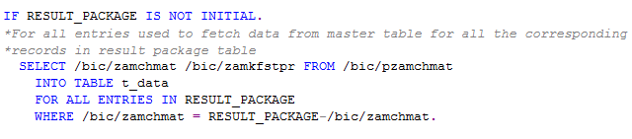

***AMDP***

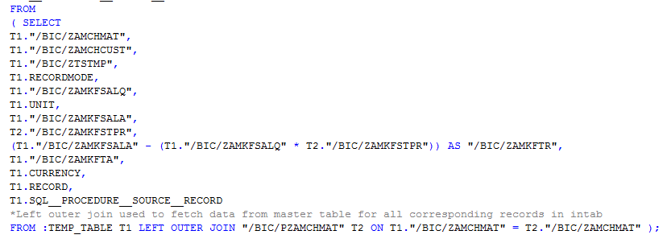

### **Loop and Read statements**

In ABAP, single record processing of data in the source and result packages is achieved with the help of LOOP-ENDLOOP and READ TABLE statements. Since LOOP-ENDLOOP along with READ statements are not compatible with AMDP script, subqueries are used to replace them.

*Note*

A calculated field cannot be used for the calculation of another field within the same SELECT. The calculation is to be carried out in the subquery and then the calculated field may be used for another calculation in the main select.

***ABAP***

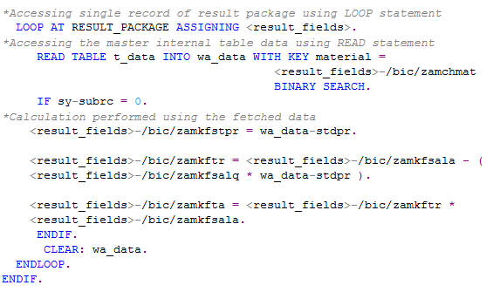

***AMDP***

